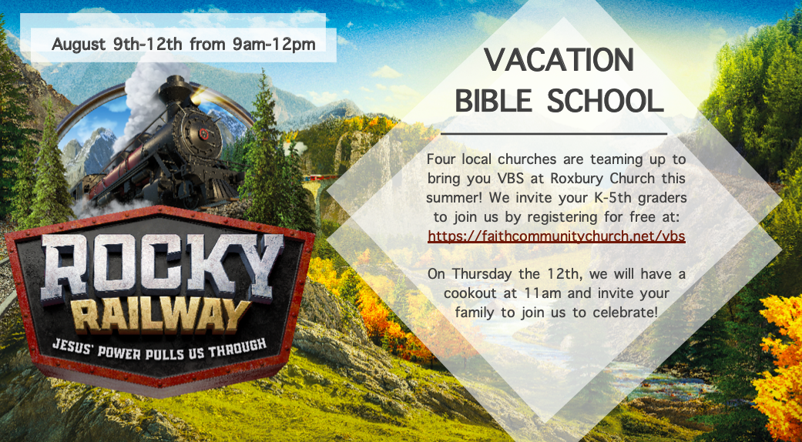
- - - - - - - - - - - - - - - - - - - - - - - - - - - - - - - - - - - - - - - - - - - - - - - - - - - - - - - - - - - - - - - - - - - - - - - - - - - - - - - - - - - - - - - - - - - - - - - - - - -

REGISTRATION
1: Name: ______________________ Gender: ______ Birthday: _________ Grade: _____
2: Name: ______________________ Gender: ______ Birthday: _________ Grade: _____
(Include any additional children on back)
Parent/Guardian Name: ______________________ Phone: ______________________
2nd Guardian/Emergency: ____________________ Phone: ______________________
Email Address: _______________________________________________
Home Address: _______________________________________________
Does your child have any food allergies? If yes, please specify:__________________________________
Have you attended one of our churches before? Yes/No If yes, which one: ________________________
How many family members (besides registered children) will be attending the Thursday cookout? _______

